Central States Communication Association
91st Annual Conference

Program Planner Guide

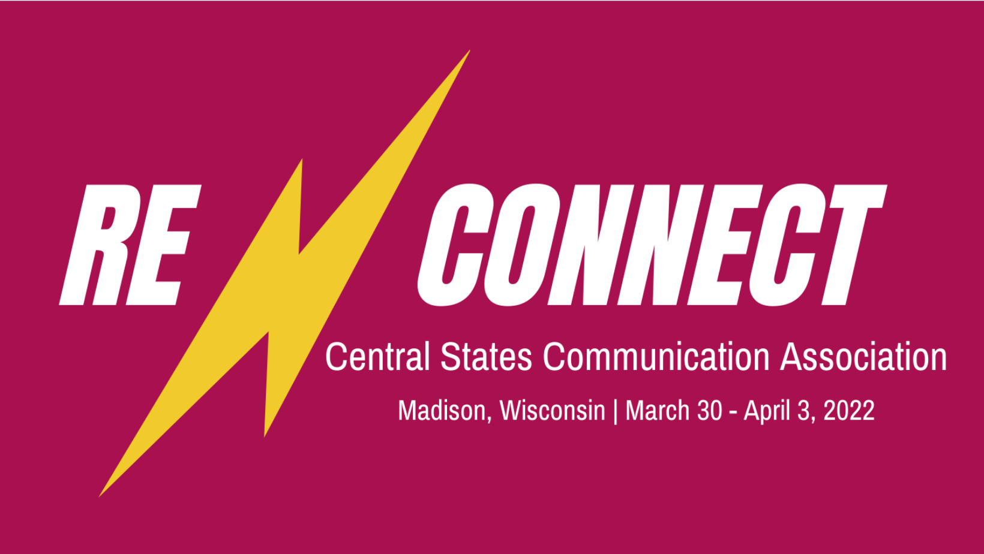

Madison Concourse Hotel
Madison, Wisconsin

Conference Planner and CSCA 1st VP:
Debbie Ford
Creighton University
DebraFord@creighton.edu

CSCA Executive Director:
Tiffany Wang
University of Montevallo
csca.ed@gmail.com

Table of Contents

Conference Theme & Call for Papers & Panels 3

Hotel Information 4

Interest Group Planners 5

Unit Slot Projections 6

Program Planner Dates and Responsibilities 7

Program Planner Responsibilities – Explanations & Tips 8

Technology Policy 14

Panel Formats 15

Forms

Unit Leadership 16
Planner’s Report to the Executive Director 17

Central States Communication Association
2022 Call for Papers & Panels

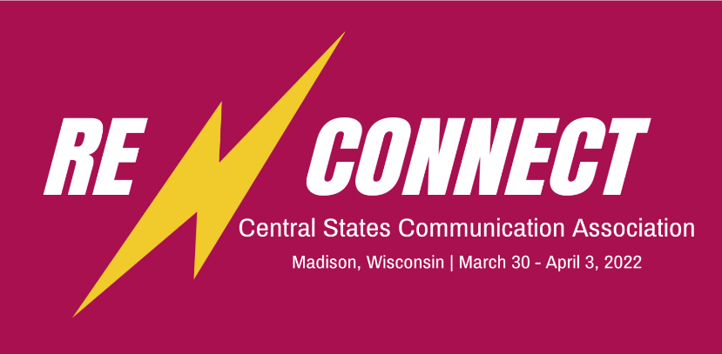

The Madison Concourse Hotel
Madison, Wisconsin | March 30-April 3, 2022

You are cordially invited to submit competitive papers, panel discussions, and performance sessions for our 91st Annual Convention in Madison, Wisconsin. Members are encouraged to reflect on the theme of Re-connect. It is time (hopefully) to come together in person after our two years of very different conference circumstances. We made it through together through many challenges—let’s celebrate together!

Our annual conference provides us an opportunity to re-connect with each other; with where we have been in our work, our discipline, and our lives overall; and with how we create our futures. It also provides us with new opportunities: How can we forge new, more inclusive paths to expansive horizons in thought, creativity, expression, and scholarship?

As I noted in 2020-2021, Central States is a space that is reinvented every time we gather together at the conference, every time we talk with a colleague, and every time we share our research, our teaching ideas, and our very selves. We are not a perfect organization. How can we re-connect--connect again, but anew, creating a more welcoming space for all our members?

Faculty, students, independent scholars, and community members are encouraged to submit and attend the convention. Institutional and community partnerships are particularly welcome. Submissions inclusive of all methodological perspectives in the communication discipline are expected and embraced. Submissions that foreground the voices of marginalized groups and underrepresented scholars are especially welcomed.

Watch for specific calls and submission information from each of the 27 CSCA Interest Groups, Caucuses, and Sections.

Questions about the general call or the 2022 conference:
- Contact Deb Ford, 2022 primary program planner (I’m baaaccckkkk….)
- DebraFord@creighton.edu.

Deadline for submissions: October 8, 2021, 11:59 PM CDT.
Hotel Information

Hotel Address and Contact Information

Madison Concourse Hotel
1 W Dayton St.
Madison, WI 53703
(800) 356-8293
https://www.concoursehotel.com/

Rate Information

Room Rates:
Concourse Level: $139
Governor’s Club Level: $189
Taxes: 15.5%
Parking: $10 per day

Rates include complimentary wifi.

More information to come about the hotel this summer.

CSCA 2022 Interest Group Planners

- Activism, Communication Ethics, and Social Justice: Wendy Anderson, University of Minnesota Twin Cities

- Adjunct and Temporary Faculty: Heather Nesemeier, Minnesota State Moorhead
- Argumentation and Forensics: Keith Bistodeau, Anoka Ramsey Community College

- Basic Course: Stevie Munz, Utah Valley University

- Communication Education: Allison Brenneise, University of Minnesota

- Communication & Technology: Jihyun Kim, University of Central Florida

- Communication Theory: Shweta Arpit Srivastava, Monmouth College

- Community College: Jacob Isaacs, Purdue University

- Ethnicity, Race, International, & Class Concerns: Eddah Mutua, St. Cloud State University

- G.I.F.T.: Rachel Collier Murdock, Des Moines Area Community College

- Graduate Student Caucus: America Edwards, University of California Santa Barbara

- Health Communication: Jenn Anderson, South Dakota State University

- Instructional Resources: Samantha Dunn, Bradley University

- Intercultural Communication: Eun Young Lee, Central Washington University

- Interpersonal and Family Communication: Lindsey Thomas, Illinois State University

- Media Studies: Kelly Adams, University of Missouri

- Organizational & Professional Communication: Tim McKenna-Buchanan, Manchester University

- Performance Studies and Autoethnography: Molly Cummins, University of Texas-Arlington

- Political Communication: Josh Bramlett, Eastern New Mexico University

- Popular Culture: Stephanie Young, University of Southern Indiana

- Rhetorical Theory and Criticism: Hilary Rasmussen, University of Wisconsin-Parkside

- Sexual Orientation and Gender Identity: William Sipe, University of Nebraska-Lincoln

- Sports Communication: David Wendt, Iowa Wesleyan University

- States Advisory Council: Anna Wright, Illinois College

- Strategic and Applied Communication: Ashleigh Day, University of Texas at Tyler

- Undergraduate Education & Administration: Donna Pawlowski, Bemidji State University

- Women’s Caucus: Lauren Johnsen, University of Memphis-Lambuth
CSCA 2022 Unit Slot Projections

CSCA 2022 will use the system for assigning slots introduced in 2021. The Executive Committee approved a unit slot projection process in November 2019 that is very similar to the process used by the International Communication Association. The First Vice President/Primary Planner (Debbie Ford) and Executive Director (Tiffany Wang) will allocate slots for your interest group based upon your total number of 2022 submissions. Below is the policy.

First, all Interest Groups, Caucuses, and Sections will be given two convention slots (one for the group’s business meeting and one for panels, discussions, and papers), if the group meets the required number for membership.

Second, after submissions close, the Executive Director and First Vice President/Primary Planner will inform unit planners of their respective total number of convention slots. The number is calculated based upon the number of submissions (your group’s submissions as a percentage of total conference submissions) divided among the available conference rooms and time slots. For example, if your group receives 5% of the submissions, your group will receive 5% of the available session slots. These slots are in addition to the two automatic slots.

CSCA 2022 Program Planner Dates and Responsibilities

Date | Responsibility
May 1, 2021 | Deadline: Submit Unit Leadership Form F to Tiffany Wang by email. If you have not done so, please email this form immediately.
June 7-11, 2021 | - Review Program Planner Guide  - Watch email for Zoom Planner Meeting to be held week of June 7th and attend Zoom session, if possible. (Email with link will be sent.)
June 11, 2021 | - Submit Unit Call for CSCA website to Debbie Ford and cc: Tiffany Wang  - Send Unit Call to unit members and encourage submissions
August 16-27, 2021 | Submit Unit Call to NCA COMMNotes, social media, etc.
September 7, 2021 | Send Unit Call to unit members and encourage submissions (1st reminder)
September 20, 2021 | Contact reviewer volunteers and verify service
September 27, 2021 | Contact unit members reminding them of upcoming deadline (Oct. 8)
October 8, 2021 | Submission Deadline. Receive submissions and prepare for review
October 12, 2021 | Deadline: Send submissions to reviewers for review
October 27, 2021 | Deadline to receive reviews from reviewers
November 12, 2021 | Deadline: Submit unit panel/paper rankings, awards, etc., to Debbie Ford
December 10, 2021 | - Receive program proofs  - Contact submitters with acceptance or rejection
December 17, 2021 | Deadline: Respond to Debbie Ford re: approval of/changes to program proofs
January 4, 2022 | Deadline: Submit Unit Planner’s Report to Tiffany Wang, cc: Debbie Ford  Contact unit members: Encourage them to register and book hotel
Feb. 1, 2022 | Contact unit members and encourage attendance
Feb. 14, 2022 | Verify respondents possess papers for review and act accordingly
Mar. 30-Apr. 3, 2022 | Enjoy the conference! See you in Madison!

CSCA 2022 Program Planner Responsibilities – Explanations and Tips

First, thank you for your important service to CSCA. The program planner plays such a fundamental role in making a great conference. I look forward to working with you in preparation for the 2022 convention. I will do my best to answer any questions you may have. If you have any questions, please contact me (Debbie Ford) at DebraFord@creighton.edu.

Attending the Unit Meeting / What to do in this year’s circumstances

The program planner is the incoming chair of the Unit and normally takes over the meeting once previous and present business has been addressed. It is the responsibility of the newly-established chair to address new/upcoming business which includes planning for the next convention. Had the 2021 Conference been held in person, members of the 2022 Conference Team would have visited the business meeting of each Unit in order to discuss the conference, answer questions, take suggestions, and encourage attendance. We will have had a chance to meet virtually during the 2021 convention, but I will have more information after our hotel site visit this summer. Thus, I will also host a Zoom session to further discuss planning in early June. The session will be recorded for those unable to attend. Please watch your email for announcements. If you have any questions, please contact me, Debbie Ford, at DebraFord@creighton.edu.

Submitting the Unit Call

Your unit most likely has a call that has been passed down and is slightly modified each year. Feel free to modify the document as you see fit. It is your opportunity to make a positive contribution and impact on the unit. However, please make your guidelines (like the due date) and procedures consistent with those of other units and with the general call to minimize confusion.

For consistency, each unit call must include the following centered at the top of the page (see page 9):

[YOUR] INTEREST GROUP
Call for Papers and Panels
Central States Communication Association (CSCA)
Annual Convention-Madison, Wisconsin
March 30-April 3, 2022
Re-Connect

Include a paragraph or two explaining the purpose of your Unit, conference theme, what types of proposals you are seeking, and what types of topics you are seeking. A list of the most common panel formats is located on Page 15. You may simply solicit topics of a general nature (see the example provided below), or you may wish to provide specific examples of topics, perhaps those generated through your business meeting emails. Indicate that strong preference will be given to those panels that include panelists from multiple institutions. Finally, if your Unit has established awards, include that information here as well.

The [your named] Interest Group invites the submission of competitive papers, panels, roundtable discussions, and innovative programming for the 2021 CSCA convention in Cincinnati, Ohio. The purpose of the [your named] Interest Group is to promote [xyz]. A range of topics encompassing [xyz] are welcome, and we especially encourage members to address issues related to the convention theme, Re-Connect. Submissions that foreground the voices of marginalized groups and underrepresented scholars are especially welcomed. Regarding panels, preference will be given to those with panelists representing multiple institutions rather than representing a single institution.

Next, include submission details for your interest group. Submission details must be included for both competitive papers and panels. For papers, remember to specify that only completed papers will be accepted and that author name(s) and identifying information must be removed.

Papers: Only completed papers will be accepted.
- Include a title and a brief abstract (required).
- Graduate students should type “STUDENT” on the upper right-hand corner of the title page.
- If the paper will be a graduate student debut, please type “DEBUT STUDENT” in the upper right-hand corner of the title page.
- To be considered a graduate student debut paper:
  - the author must be a graduate student,
  - the paper must have single authorship, and
  - the paper must be the author’s first paper to be presented at CSCA.
- If you would like your paper to be considered for the Inclusive Scholarship Award, type “INCLUSIVE SCHOLARSHIP” in the upper right-hand corner of the title page.
  - To be considered as an exemplar of inclusive scholarship, the paper must demonstrate academic rigor in the examination of communication and historically marginalized communities/populations.

Next, include notice that technology requests must be made at the time of submission. The association’s complete technology policy can be found below. Finally, include the deadline for submissions and where to send submissions.

All technology requests must be made at the time of submission.
Submissions must be received by 11:59 PM, CDT, October 8, 2021.
Send submissions electronically through our online system via the CSCA website.

Please encourage submitters to be sure that all potential presenters create a profile on the CSCA convention webpage. Membership is not required to create a profile. This will make later steps in the process much easier.

Contacting Unit Members

Some units maintain a dedicated social networking site page. This is a helpful way to provide information about the convention, to enable members to maintain contact as well as to generate and collaborate on ideas, and to provide information about the convention and to encourage attendance. If your unit does not have such a site, you may want to consider developing one while you serve as program planner for your group.

At minimum, you should maintain contact with your group through email. Correspondence through email is encouraged even with the above resources, since many members may not visit the social networking site page or participate in the listserv.

To contact all members of the Unit, all you have to do is submit your message to Debbie Ford at DebraFord@creighton.edu. Please do not send them to Kathie Cesa.

Tips:
- Encourage potential submitters to put people representing multiple institutions on their panels. Additionally, no one person should serve more than one role on a panel. For example, a chair should not be a paper presenter or discussant on the same panel.
- It is good to keep in contact with members, but do not overwhelm them with messages. Keep in mind that our members have multiple Unit affiliations and receive email from all of them.
- Be sure to provide members with relevant information but also be sure to generate excitement and encourage participation. This is an opportunity for you to assist the association and to develop the presence of your group.

Submitting Unit Call to COMMNotes

CSCA is always looking to attract new members and to include people from beyond the region. COMMNotes (https://www.natcom.org/commnotes-subscription-page) is one way to reach nonmembers of the association. Also feel free to submit the call for your unit to other listservs associated with the focus of your group and to send the call for your unit to scholars who may be affiliated with your area but who are not members of the association.

Tips:
- When submitting the call on COMMNotes or other listservs, do not just use Call or Call for Papers and Panels or something similar as your title, since such titles will likely not catch the attention of interested parties when presented at the top of the message. Instead, use a title that ensures readers will know what your announcement entails. For instance: CSCA 2022 “Re-Connect” Call for Papers and Panels. You may also want to include the name of your unit in the title.

- Note: when submitting the call on COMMNotes or other listservs, be aware that formatting (bolding, italics, and tabs) may not transfer and may interrupt the spacing of your post. Accordingly, it is best to remove such formatting prior to submitting your post.

Receiving Submissions and Preparing for Review

For competitive papers, verify that the paper does not include an author name or any other identifying features (be sure to check the Properties). If the online submission is incomplete, or if the paper includes identifying material, notify the submitter what must be done in order to ensure review.

When sending papers and panels to reviewers make sure to include: (a) how many papers/panels are being sent for review, (b) specifications and guidelines for reviewing, and (c) the deadline to submit reviews.

Tips:
- When preparing competitive papers for anonymous peer review, make sure author identification is not evident in the Properties section or in the author signature section of the document.

- One reviewer should be able to handle around 6-8 submissions in the specified timeframe. You are strongly urged to use three reviewers for each submission, if at all possible. Thus, Reviewers 1, 2, and 3 could review Submissions #1-8. Reviewers 4, 5, and 6 could review Submissions #9-15, and so on. It is important to balance the number of submissions so one person is not reviewing more or less than other members.

- As the deadline for reviews nears, send a reminder to reviewers about the approaching deadline. If you have not received materials from a reviewer by the day after the deadline, it is more than acceptable to contact them.

- Unfortunately, sometimes a reviewer does not complete the assignment. Consider calling upon a unit member who has not reviewed for you to complete the task, being careful not to give them more than they can handle in the extremely short turnaround time. In fact, it may be necessary to split one reviewer’s load among two members.

- Keep all documents related to the programming of your group until after the convention.

Preparing and Submitting Proposal Forms

Once the reviews are returned, begin preparing and submitting the panel proposals for your group. In doing so, you will: (a) organize your papers into panels in the online system; (b) rank your panels within your division; (c) submit online forms for top competitive paper, panel, and other division/caucus awards; and (d) submit the Student Debut Paper.

Developing Competitive Paper Panels: First, develop panels for the competitive papers. These panels usually include at least three but no more than five papers. These panels will also need to have a chair and a respondent. As with the guidelines set for paper panel submissions, a single person should not assume both chair and respondent roles. Rewarding paper reviewers with these positions is customary, but you may also draw from your list of volunteers from the previous business meeting. In either case, make sure you contact each person to make sure they are willing to serve in this capacity before assigning them the role. You will also need to develop a title and description for each competitive paper panel created.

Tip: When developing titles for competitive paper panels, strive to develop titles which include the conference theme, are memorable, and are likely to draw an audience. This same advice applies to the descriptions of these panels.

Ranking Your Panels: To help Debbie Ford slot your panels, you must rank all the panels you are submitting from the highest-rated to the lowest-rated. The highest-rated panels will usually receive the most favorable time slots, while the lower-rated panels will usually receive less favorable time slots. Generally, competitive papers, especially those featuring top-ranked or award-winning papers, are ranked near the top of this list. However, the ranking of your panels is based on your discretion.

Tips:
- Although it is advisable to pay close attention to the feedback of your reviewers, you ultimately decide the rankings of your group. Accordingly, if you disagree with how the rankings turn out, you are not bound by them. You are the program planner for your unit and are ultimately responsible for what is moved forward.
- As program planner for your group, it is also your prerogative to develop a premier panel or panels of your own. These panels should include the best of the best scholars in your area and ideally correspond with the convention theme.
- It is not necessary to include your unit’s business meeting on this list.

Organizing Panels in Online System: In the online system, you will be able to create the paper panels (i.e., put the papers into groups). This will include a program copy of the panel, exactly as it may appear in the program. A discussion panel model and a paper panel model are included on this form to help guide you in the completion of the program copy.

Tips:
- You must use your editorial license to rewrite the program descriptions and program titles as you see fit so that they are grammatically correct and clear.

- Be sure to remind members to include accurate information in the AI Profile. This is how names and affiliations will appear in the program.

Reviewers for your Group: In the online system, you will be able to assign reviewers. We should be able to pull this information from the online system, but if not, Debbie Ford will ask you for these names so that they can be acknowledged for their service in the program.

Tips:
- Only include those individuals who actually completed reviews. Do not include those individuals who volunteered, but ultimately could not serve or those individuals who never returned their reviews.
- Make sure names and affiliations are consistent as discussed above.

Top Paper/Panels: If your group has an award for the top competitive paper and/or the top panel, we will ask you for this information in one place either online or in a form that Debbie Ford will provide. If you have a Top Paper Panel, be sure to name it Top Paper Panel and the name of your Interest Group/Caucus.

Tips:
- When completing the paper awards, include all authors if the paper is a co-authored piece. When completing the panel award, include all participants (i.e., chair, presenters, and respondent, if applicable).

- Make sure names and affiliations are consistent as discussed above.

Top Graduate Student Paper: Submit this information only if your Unit received graduate student debut paper(s). Send the completed form and an electronic copy of the paper so that it may be considered for the Past Officers’ Graduate Student Debut Program award. To be eligible for participation in the Debut Program, (a) the author must be a graduate student, (b) the paper must have single authorship, and (c) the paper must be the author's first paper to be presented at CSCA.

Submitting all of this information: These forms are due no later than November 12, 2021. However, please send them as soon as they completed; the earlier the better.

Receiving and Responding to Program Proofs

You will receive program proofs on or about December 10, 2021 and will need to return them with corrections by Dec. 17, 2021. It is very important that these proofs are reviewed carefully and completely.

Contacting Submitters with Acceptance or Rejection: Once you have received and reviewed the proofs, you will be able to contact submitters about the status of their submissions. It is imperative that you contact everyone who submitted. Failure to do so is extremely unprofessional and discourteous. In the online system, you should be able to assign the respondents so that they can see the papers they need to respond to electronically. Do not let anyone know about days and times of panels, since these may change between this point and the final version of the program. Remember to contact chairs and respondents of competitive paper panels as well.

Tips:
- When contacting submitters be sure to include the specific title of the submission and the Unit you are representing.

- Regardless of the status of their submission, genuinely thank the person for their submission.

- Use tactful professionalism when rejecting a submission. When you reject a competitive paper, include a rationale for the rejection. Be kind, informative, and supportive. Encourage revision and resubmission for CSCA 2022. The same approach applies, although to a lesser degree, when rejecting panels. People will remember how you offer rejection of a submission more than how you offer acceptance of a submission. When rejecting a submission, indicate that you still hope to see the person at the conference and encourage their attendance.

- Let all submitters know that they will receive information about the conference program, registration, and hotel registration in January. Remind them that the conference hotel will fill quickly, and so they should reserve as soon as possible if they wish to stay at the official conference hotel.

Submitting Your Unit Report to the Executive Director
Each Unit must send the 2022 Program Planner’s Report to Tiffany Wang, CSCA Executive Director, by Jan. 4, 2022. Failure to do so means that your Unit will not have award certificates for the convention, nor will your Unit be able to spend any of its $100 allocation. See this form for more details, including Tiffany’s contact information.

Technology Policy

CSCA will attempt to provide multimedia projectors and speakers based on financial resources to all presenters who request them at the time of the program submission.

CSCA is unable to approve requests for equipment such as personal computers, laser printers, satellite links, teleconference equipment, DVD players, or Internet access. CSCA members or individuals attending the convention either may elect to rent such equipment from the convention hotel at their own personal expense or may bring their own equipment, unless prohibited by the convention hotel. (Please check beforehand with the Executive Director about the convention hotel policy). If individuals provide their own equipment, the hotel may elect not to assist if service is needed. If the hotel does assist and assesses a fee, the individual requesting assistance is responsible for all charges.
Any technology request made by CSCA participants at the convention that was not requested at the time of the program submission cannot be charged to CSCA.

Panel Formats

The most common panel formats are listed below along with their descriptions. However, feel free to be creative in the design of the panels that are developed and proposed.

Competitive Paper Panels are those including competitively-selected papers grouped together by the program planner. These panels must have a chair to introduce each paper and to moderate the discussion, as well as a respondent to discuss connections between the papers and to provide supportive criticism and guidance. Scholars filling these roles will be selected by the program planner. Generally, these panels will include at least three but no more than five papers. It is especially important to limit the number of papers included so that sufficient time is allowed for the delivery of the papers, for the respondent’s feedback, and for the audience to provide questions and reactions following delivery of the papers and the response.

Paper Panels are those including completed papers encompassing a specific topic. These panels must have a chair, but a respondent is not always necessary. Generally, these panels will include at least four but no more than five panelists. Audience questions and reactions usually are reserved until after everyone on the panel has presented their paper.

Discussion Panels are those including 4-7 panelists who provide a brief opening statement concerning a topic and then engage in discussion. These panels must have a chair to introduce the panelists and to moderate the discussion. Audience questions/participation are encouraged.

2021-2022 UNIT LEADERSHIP (Form F)
Please complete and return as soon as possible to Tiffany Wang, csca.ed@gmail.com.

Unit Name: _________________________________________________________________

Chair

Professional Name: _______________________________________________________

Affiliation: ____________________________________________________________

Address: ____________________________________________________________

Email: ____________________________________________________________

Telephone: ____________________________________________________________

Vice-Chair

Professional Name: _______________________________________________________

Affiliation: ____________________________________________________________

Address: ____________________________________________________________

Email: ____________________________________________________________

Telephone: ____________________________________________________________

Secretary

Professional Name: _______________________________________________________

Affiliation: ____________________________________________________________

Address: ____________________________________________________________

Email: ____________________________________________________________

Telephone: ____________________________________________________________

2022 Planner’s Report to the Executive Director

Please submit to Tiffany Wang at csca.ed@gmail.com by Jan. 4, 2022.

Planner Name:

Planning Unit:

Email: Phone:

UNIT AWARD INFORMATION. If you do not offer an award in a specific category, please mark with N/A.

- Top Paper Title:
Author(s), title(s), and institution(s):

Quote about paper from planner (to be used in press releases):

- Top Student Paper Title:
Author(s), title(s), and institution(s):

Quote about paper from planner (to be used in press releases):

- Top Panel Title:
Author(s), title(s), and institution(s):

Quote about paper from planner (to be used in press releases):

EXPENDITURES.

Do you give cash awards for your awards? If so, please list the amounts for each here and who should receive the check. This information should be in your Unit bylaws. Remember, only one check can be written for each award.

Do you have any other expenses you wish to have covered? Remember, unless you have an endowed award within your Unit, you are limited to $100 worth of expenditures each year. Please review the bylaws (online – see the CSCA website) to examine how money can be spent.

Failure to submit by the Jan. 4 deadline will result in forfeiture of awards and funds. Unfortunately, no exceptions can be made for this rule.

